**DECLARATION**



I hereby declare that project work entitled “INDUSTRIAL TRAINING REPORT” Submitted to A.K.T.U., Lucknow, is a bonafide and genuine work carried out by us under the guidance of Mr. Neeraj Suyal formed the basis for the award of any diploma, degree association ship or fellowship of other university or institute. I also declare that the material entitled it is original and the same has not previously.

Date :

Place: Nawabganj Bareilly (U.P) Submitted by: Harshit

Roll No: 2009560500021

### CERTIFICATE



This is to Certified that Harshit has carried out the project work entitled “Industrial Training” for the award of BACHELOR OF PHARMACY From Dr. A.P.J. Abdul Kalam Technical University, Lucknow under my supervision. This project report work and the studies carried out by the student and the content of the report do not form the award of any other degree to the candidate or to anybody else.

Mr. Neeraj Suyal Dr. Hemendra Gautam

(Associate.Professor) (Director)

Arya College of Pharmacy Arya college of Pharmacy

Nawabganj Nawabganj

### ACKNNOWLEDGEMENT

I have taken effort in this report which came to completion with support of many people. I am highly indebted to **ARYA COLLEGE OF PHARMACY , NAWABGANJ BAREILLY.**

I would like to express my special thanks of gratitude to my teacher MR. Neeraj Suyal for his guidance and constant supervision as well Ad for providing necessary information regarding the report and also for his support in completing the report as well as gave me a golden opportunity to do this training which also helped me in doing lot of researches. I came to know about so many new things .I am really thankful

Secondly I would also like to thank my parents and friends who helped me a lot in finalizing this report within the limited time frame.

Name: Harshit B.Pharm 6th Sem

Roll No : 2009560500021

Arya college of Pharmacy Nawabganj

### S. No. CONTENT PAGE NO.

1. Company Profile 1
2. Layout 2
3. Product list 3
4. Lay out of tablet Manufacturing layout 4
5. Tablet 5
6. Types of tablet 5-10
7. Manufacturing of Compressed Tablets 11-12
8. Excipients used in formulation of tablets 12-13
9. Manufacturing Defects in tablets 14-15
10. Coating of tablet 16
11. Evaluation of tablet 17-19
12. Pharmaceutical packing 20
13. Types of packing 20-26
14. Conclusion 27

COMPANY PROFILE

Akums began its journey in 2004 with a single manufacturing unit at Haridwar. With the constraints of limited resources, the following years proved remarkable to grow exponentially. However, limitations never hindered growth; in fact, they doubled the confidence of the visionaries to lead the company to a new height.



**LAYOUT**

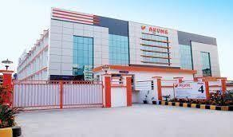

|  |  |
| --- | --- |
|  | **Akums Product list ( Tablets )** |
| S.NO. | TABLETS |
| 1. | CALCITIN TABLETS 1000 mg |
| 2. | ASPIRIN TABLETS I.P 300 mg |
| 3. | ASCORBIC ACID TABLETS I.P.500 mg |
| 4. | CALCIUM LACTATE TABLETS IP 300 mg |
| 5. | CIPROFLOXACIN HCL TABLETS IP 4 mg |
| 6. | DIAZEPAM TABLETS IP 5 mg |
| 7. | DICLOFENAC SODIUM TABLETS IP 50 mg |
| 8. | MEBENDAZOLE TABLETS IP 100,200 mg |
| 9. | ALBENDAZOLE TABLETS IP 400 mg |

**Layout of Tablet Manufacturing Section**

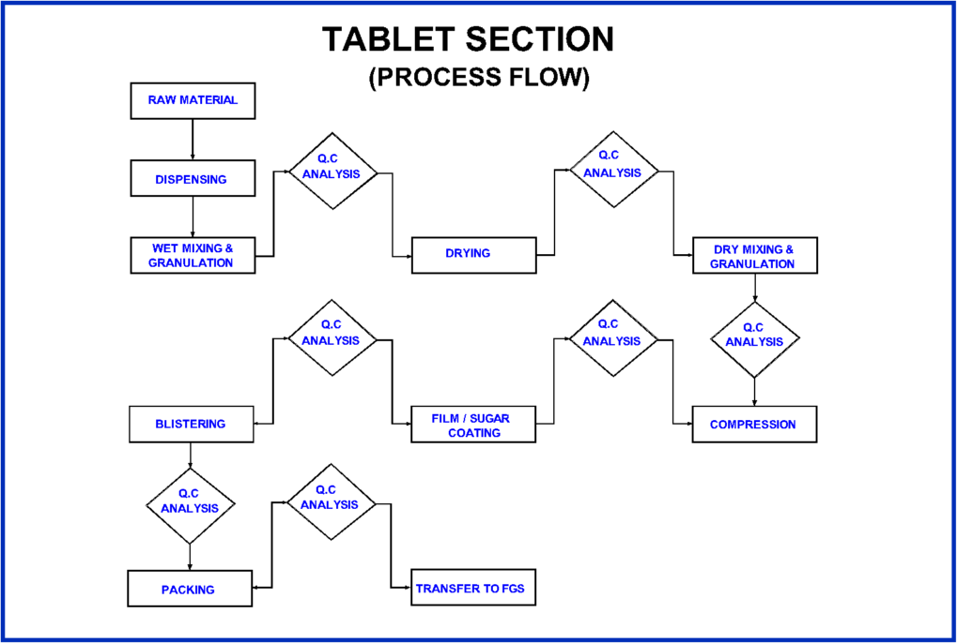

**TABLET**

* According to USP, Tablet is defined as a compressed solid dosage form containing medicaments with or without Excipients.
* According to the Indian Pharmacopoeia, Pharmaceutical tablets are solid, flat or biconvex dishes, unit dosage form, prepared by compressing a drug or a mixture of drugs, with or without diluents.

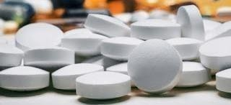

### ADVANTAGE OF TABLETS

* + Easy to be administered
  + Easy to be dispensed
  + More stable dosage form
  + Maintain accuracy of dosage
  + Lightest and the more compact
  + Cheapest in packing and export
  + Longer expiry date

### DISADVANTAGE OF TABLETS

* + Difficult to swallow in case of children and unconscious patient.
  + Poor wetting drug have slow dissolution properties.
  + Can not use in emergency cases.

### TYPES OF TABLETS:

1. **Tablets ingested orally:**
   * Compressed tablets
   * Multiple compressed tablets
   * Enteric coated tablets
   * Sugar coated tablets
   * Film coated tablets
   * Chewable tablets

### Tablets used in the oral cavities:

* + Buccal Tablets
  + Sublingual tablets
  + Lozenges
  + Dental cones

### Tablets administered by other routes:

* + Implantation tablets
  + Vaginal tablets

### Tablets used to prepare solutions:

* + Effervescent tablets
  + Dispensing tablets
  + Hypodermic tablets
  + Tablet triturates

#### Tablet ingested orally -

They are designed to be swallowed as they are except the chewable tablets.

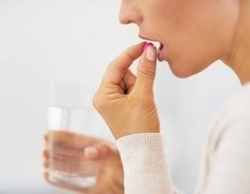

They are categories in - **types of tablet**

### Compressed Tablets

Ex: Paracetamol

### Multiple compressed tablets

They are one type of extended or modified release tablet.

Usually contain two single doses of medication one for immediate and one for delayed release.

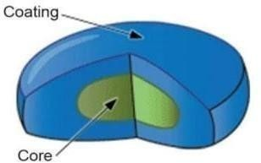

### Multilayered tablets

**Multilayer tablet** consists of layers of drug with different release rate, having ability to prevent drug-excipient incompatibility. It provides multiple release kinetics profile in single delivery system of one or more drugs.

### Sustained action tablets

A tablet that releases its active ingredient in specified doses at timed intervals.

### Enteric coated tablets

Prevent the drug from early dissolution or disintegration by gastric acid, help the drug to pass the gastric.

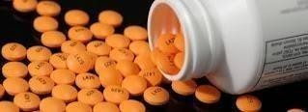

### Sugar coated tablets

A **sugar**-**coated tablet** is **coated** with **sugar** to disguise the taste.

### Film coated tablets

Film coated tablets is a process in which a tablet, capsule, or pellet is covered by a thin layer of film to protect it or make it easier to swallow.

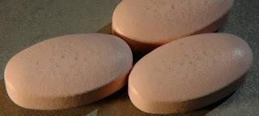

### Chewable tablets

Chewable tablets are an oral dosage form intended to be chewed and then swallowed by the patient rather than swallowed whole.

They should be designed to be palatable and be easily chewed and swallowed.

1. ***Tablet used in oral cavity -***

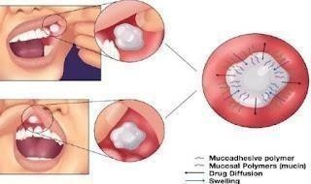

### These are categories in - Types of tablet

1. **Buccal tablets**

Buccal tablet one which dissolves when it is held between the cheek and gum, permitting direct absorption of the active ingredient through the oral mucosa.

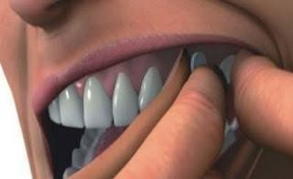

### Sublingual tablets

Sublingual administration involves placing a drug under your tongue to dissolve and absorb into your blood through the tissue there.

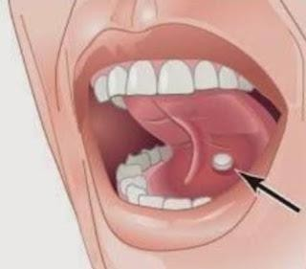

### Lozenge tablet and troches

A throat lozenge (also known as a cough drop, troche, cachou, pastille or cough sweet) is a small, typically medicated tablet intended to be dissolved slowly in the mouth to temporarily stop coughs.

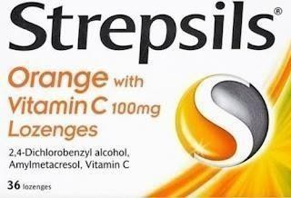

### Dental Cones

These are relatively minor compressed tablets meant for placing them in the empty sockets after tooth extraction.

They prevent the multiplication of bacteria in the socket following such extraction by using slow- releasing antibacterial compounds or to reduce bleeding by containing the astringent.

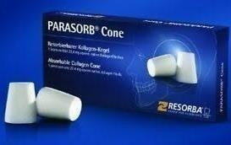 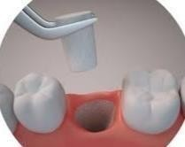

#### Tablets administered by other routes

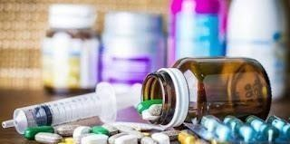

These are categories in- **types of tablet**

### Implantation tablets

These tablets are placed under the skin or inserted subcutaneously by means of minor surgical operation and are slowly absorbed.

These may be made by heavy compression but are normally made by fusion.

The implants must be sterile and should be packed individually in sterile condition.

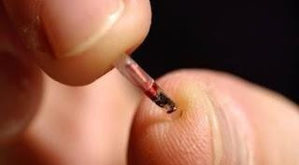

### Vaginal tablets

Tablet contains clotrimazole, an antifungal medicine.

It is used in the treatment of fungal infection of the vagina and helps in relieving symptoms of fungal infection of the vagina.

#### Tablets used to prepare solutions

These are categories in- **types of tablet**

### Effervescent Tablets

Tablets are also a common intervention for gastric problems like heartburn, upset stomach, and acid indigestion.

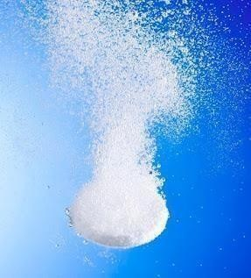

### Dispensing Tablets

A tablet prepared by molding or by compression; used by the dispensing pharmacist to obtain certain potent substances in a convenient form for accurate compounding.

"A tablet that contains a clinically effective large amount of an effective drug".

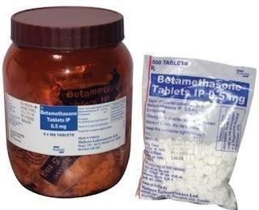

### Hypodermic Tablets

Hypodermic tablets are soft, readily soluble tablets that were originally used by physicians in extemporaneous preparation of parenteral solutions. These tablets are dissolved in a suitable vehicle (water for injections) and administered by parenteral route.

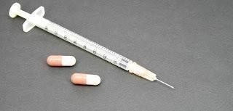

### Triturates

A tablet made by moistening the medication mixed with a powdered lactose or sucrose and then **molding** it into shape and allowing the liquid to evaporate.

It usually disintegrates readily.

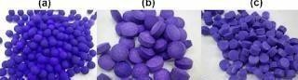

**MANUFACTURING OF COMPRESSED TABLETS -**

**Tableting methods**

* 1. Wet methods – Wet granulation
  2. Dry methods – Dry granulation
  3. Direct compression

### WET GRANULATION:

Raw materials → Weighing → Screening → Wet massing → Wet Sieving/Milling → Drying → Dry Screening → Mixing → Compression

* The powder mass is wetted with the binding solution until the mass has the consistency of damp snow.
* If the granulation is over wetted the granules will be hard, if not wetted sufficiently, the resulting granules will be too soft, breaking down during lubrication.
* The wet mass is forced through a suitable sieve.
* Moist materials from wet milling steps is placed on large trays and placed in drying chambers.
* After drying granulation, the lubricant or glidants are added as fine powder to promote flow of granules.
* These granules then compressed to get tablet.

### DRY GRANULATION:

Raw material → weighing → Screen → Mixing → Slugging → Milling → Screening → Mixing → Compression

* Compression granulation involves the compaction of the components of a tablet formulation by means of flat punch.
* These compact masses are called slug and the process is called slugging. Slugs are then milled and screened to produce a granular form.

### DIRECT COMPRESSION:

Raw material → Weighing → Screening → Mixing →Compression.

* This method is applicable for crystalline chemicals having good compressible characteristics and flow properties such as: Potassium salt (chlorate, chloride, bromide), Sodium chloride, Ammonium chloride, Methenamine etc.
* Tablets are compressed directly from powder blends of the active ingredient and suitable excipients
* No Pre treatment of the powder blends by wet or dry granulation procedures is necessary.

**EXCIPIENTS USED IN FORMULATION OF TABLETS**

These are the substances added in the manufacturing of tablet and perform following functions:

#### DILUENTS

Diluents are fillers used to make up required bulk of the tablet when the drug dosage itself is inadequate to produce the bulk.

Provide better tablet properties such as improved cohesion or to promote flow.

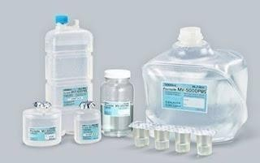

**PROPERTIES OF DILUENTS**

1. They must be non toxic
2. They must be commercially available in acceptable grade.
3. Their cost must be low
4. They must be physiologically inert
5. They must be physically & chemically stable by themselves & in combination with the drugs

**EXAMPLES :** Lactose starch, Microcrystalline cellulose, Dibasic calcium phosphate dehydrate Calcium sulphate dihydrate, Mannitol, Sorbitol, Sucrose, Dextrose

#### BINDERS AND ADHESIVE

These materials are added either dry or in liquid form to form granules or to promote cohesive compacts for directly compressed tablet.

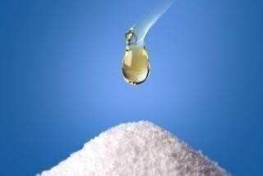

**EXAMPLES:** Natural gums: Acacia, tragacanth - 10-25% Conc solution, Cellulose derivatives: Methyl cellulose, Hydroxy propyl methyl cellulose, Hydroxy propyl cellulose.

Natural protein: Gelatin- 10-20% solution, Glucose: 50% soln in water Synthetic polymer: Polyvinylpyrrolidone (PVP)- 2% conc.

#### DISINTEGRATING AGENTS

Facilitate the breaking or disintegration of tablet when it contacts water in the GIT. Draw water into the tablet resulting in swelling and cause the tablet to burst apart. Help in dissolution of the drug and attainment of high drug bioavailability.

They can increase in volume in the presence of water by 200 to 500%.

**EXAMPLES:** Starch, Starch derivatives – carboxymethyl starches, Pre-gelatinized starches (5%) bentonite, Microcrystalline, Cellulose derivatives- arboxymethylcellulose, polyvinylpyrrolidone

#### LUBRICANTS

**Lubricants** are intended to reduce the friction during tablet ejection between the walls of the tablet and the walls of the die cavity in which the tablet was formed.

**Ex:** -Stearic acid salts – Calcium and Magnesium stearate - Stearic acid

#### ANTIADHERENTS

**Antiadherents** are intended to reduce sticking or adhersion of tablet granulation or powder to the faces of the punches or to the die walls.

**Ex:** Starch, talc , magnesium stearate

#### GLIDANTS

**Glidants** are intended to promote flow of granules or powder material by reducing the friction between the particles.

**Ex:** Corn Starch, conc. Talc.

* + ***COLORING AGENTS***

### PURPOSE:

1. Masking of color drugs
2. Product Identification
3. Production of more elegant product Two forms of colors are used in tablet preparation.

#### FLAVOURING AGENTS

Used in chewable tablets or tablets intended to dissolve in mouth.

Flavor oils are used and are added to tablet granulations in solvents, are dispersed on clays and other absorbents or emulsified in aqueous granulating agent.

The maximum amount of oil that can be added is 0.5 -0.75%.

#### SWEETENING AGENTS

Used only in chewable tablets to exclude or limit the use of sugar in the tablets.

**EXAMPLES**: Saccharine

**MANUFACTURING DEFECTS IN TABLETS**

1. **Capping**: The upper or lower segment of the tablet separates horizontally, either partially or completely from the main body and comes off as a cap, during ejection from the tablet press, or during subsequent handling.

### Causes and Remedies of Capping

* 1. Large amount of fines in the granulation.
  2. Too dry or very low moisture content, Moisten the granules suitably.
  3. Not thoroughly dried granules. Dry the granules properly.
  4. Insufficient amount of binder or improper binder, use proper binding agent to overcome this problem

### Picking and Sticking

**Picking:** the material picked up by the upper punch of machine from the upper surface of the tablet.

**Sticking:** the material is stick in the bottom or walls of the die.

### Causes:

1. Presence of moisture in granules.
2. Defect in formulation.

### Remedies:

1. Use dry granules.
2. A new set of dies.
3. **Mottling:** Unequal distribution of color on the surface of the colored tablet.

### Causes:

1. Migration of dye in the granulation.
2. uses of different type of coloration, excipients & Medicament.

### Remedies:

1. Drying the granules on law temperature.

**4. Weight variation:** Its means during the compression of tablets they don't have uniform weight.

### Causes:

1, Granules are not in uniform size.

1. No proper mixing of lubricants.
2. Variation in the speed of tablet machine.

The defect can be avoided by correcting and checking the above point

1. **Hardness variation:** Tablet do not have a uniform weight. hardness depend on the weight of the material and the space between upper and lower punching.

**Factor affecting hardness of tablets** this problem may overcome by the settings of dies.

**COATING OF TABLETS**

Tablets are coated for the following purpose;

* 1. To mask the unpleasant taste
  2. To improve the appearance
  3. To prevent the medicament from atmospheric efet
  4. To produce the sustained release product

### TABLETS ARE COATED BY FOLLOWING PROCESS

**Types of tablet coating**

1. Pan coating
2. Press Coating

### Pan coating:

It is used for **sugar coating, film coating, or enteric coating**.

The coating is done in a pan made of metal pan rotated by a motor tablets to be coated fill in the pan provide hot air maintain the speed in such a way that the tablet remain separate from each other in pan after coating polishing is done in polishing pan.

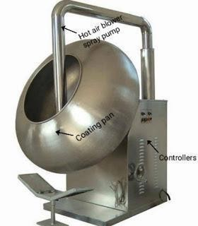

### Press coating:

The granules of coating material are prepared a layer of coating material is placed on the performed tablet, it is done in **Drycota Rotary Tablet Machine**

**EVALUATION OF TABLETS**

* + **Shape of tablets** : Size & Shape can be dimensionally described & controlled. The thickness of a tablet is only variables.Tablet thickness can be measured by micrometer or by other device. Tablet thickness should be controlled within a ± 5% variation of standard value.
  + **Appearance :** The general appearance of a tablet, its visual identity and overall “elegance” is essential for consumer acceptance, for control of lot-to-lot uniformity Appearance of a tablet involved the measurements of a tablet’s:- Size, Shape, Colour, Odour, Taste, Surface texture
  + **Content of active ingredients :** The weight of the tablet being made is routinely measured to help ensure that a tablet contains the proper amount of drug. As per indian pharmacopoeia (IP) weight 20 tablets selected at random and determine the average weight 12.
  + **Uniformity of weight :** 20 tablets are weighed. The average weight was determined. Then, tablets was weighed individually and for each tablet, the percentage of deviation of its weight from the average weight was determined.

### Disintegration test for tablets :

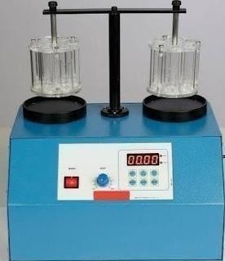

**Factor affecting disintegration of tablets Disintegration Test (U.S.P.):**

* The U.S.P. device to test disintegration uses 6 glass tubes that are 3inch long; open at the top and 10 mesh screen at the bottom end.
* To test for disintegration time, one tablet is placed in each tube and the basket rack is positioned in a 1- L beaker of water, simulated gastric fluid or simulated intestinal fluid at 37

± 2

* Move the basket containing the tablets up and down through a distance of 5-6 cm at a frequency of 28 to 32 cycles per minute.

Floating of the tablets can be prevented by placing perforated plastic discs on each tablet.

1. According to the test the tablet must disintegrate and all particles must pass through the 10 mesh screen in the time specified.
2. If any residue remains, it must have a soft mass.
3. Disintegration time: uncoated tablet: 5-30 minutes Coated tablet: 1-2 hours

### Dissolution test for tablets :

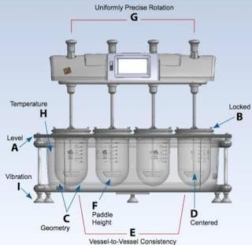

Dissolution is the process by which a solid solute enters a solution.

In the pharmaceutical industry, it may be defined as the amount of drug substance that goes into solution per unit time under standardized conditions of liquid/solid interface, temperature and solvent composition.

Dissolution is considered one of the most important quality control tests performed on pharmaceutical dosage forms.

Now it developing into a tool for predicting bioavailability, and in some cases, replacing clinical studies to determine bioequivalent.

Dissolution behavior of drugs has a significant effect on their pharmacological activity.

In fact, a direct relationship between in vitro dissolution rate of many drugs and their bioavailability has been demonstrated.

It is generally referred to as in vitro-in vivo correlation (IVIVC) **Apparatus-1** (Basket Type)

A single tablet is placed in a small wire mesh basket attached to the bottom of the shaft connected to a variable speed motor.

The basket is immersed in a dissolution medium contained in a 1000 ml flask. The flask is cylindrical with a hemispherical bottom.

The flask is maintained at 37±0.5˚ C by a constant temperature bath.

The motor is adjusted to turn at the specified speed and sample of the fluid are withdrawn at intervals to determine the amount of drug in solutions.

### Friability test for tablets:

Friability testing is a method, which is employed to determine physical strength of uncoated tablets upon exposure to mechanical shock and attrition.

In simple words, friability test tells how much mechanical stress tablets are able to withstand during their manufacturing, distribution and handling by the customer.

Throughout pharmaceutical industry, friability testing has become an accepted technology and the instrument used in to perform this process is called Friabilator or Friability Tester.

In **friability test**, samples are counted and weighted then tumbled in rotating drums with baffles, when the process is stopped; samples are moved out from the instrument, wiped-off dust and weighted again.

The difference between the weight before and after the process is determined as Friability and should not exceed 1%, which is considered an ideal percentage.

In some cases, where diameter of tablets is greater than 13mm, such tablets are tested on drums 10° tilted.

### Friability Test Apparatus for tablets

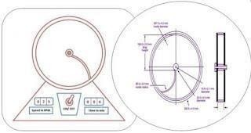

**Friability Tester:** brings to you friability testers often called friabilators for accurate friability determination of compressed and uncoated tablets.

These instruments are available with 1 or 2 drums as required.

Confirming to specifications of USP, BP and EP, our friability testers offer reliable results, while providing you ease of operation through advanced designing and configuration of the machine.

**Friability Tester** offers many user-friendly features essential for fast working and accurate testing all the time; automatic pre-set count stop, audible alarms for user alert, a provision to connect dot matrix printer and digital weighing balance, in-built self validation program.

The instrument is easy to use and maintain



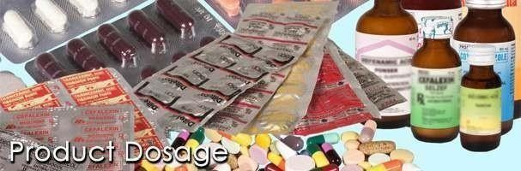

# PACKEGING SECTION

Packaging is the science, art and technology of enclosing or protecting products for distribution, storage, sale, and use. Packaging also refers to the process of design, evaluation, and production of packages. Package labeling or labeling is any written, electronic, or graphic communications on the packaging or on a separate but associated label.

## Types of packaging:

There are two types of packaging-

### Primary packaging.

1. **Secondary packaging. 1-PRIMARY PACKAGING:-**

It is the packing which is in contact with medicament (capsule or tablet).

1. **Blister packaging:-**
   * In this PVC and Al Foil is used for packaging.
   * Sometimes Al foil is used wholly for packaging-
     + Thickness of Al foil = 0.025mm ± 10%.
     + Thickness of PVC = 0.25 mm ±10%.
   * The blister package is formed by heat- softening a sheet of thermoplastic resin and vacuum drawing the softened sheet of plastic into a contoured mold.
   * Blister packaging machine consist of-
     + Feeder (vibrator).
     + A guide track.
     + A forming dies.
     + Forming heater.
     + Sealing heater.
     + Cutter.
     + Printing registration controller.

### Blister Packaging

**TEMPRATURE:-**

* + - Forming heater = 140º-170º C.
    - Sealing heater = 170º-200º C.

1. **Strip packaging:-**

The strip package is form by feeding to webs of a heat sealable flexible film through either a heated crimping roller or a heated reciprocating platen. In this the product is drop into the pocket formed prior to forming the final set of seals.

**Machine:-**

* + It consist of –
    - Hopper.
    - Disc.
    - Channel (chute).
    - Two rollers (for Al foil).
    - Cutter (center cutter).
    - Conveyer belt.
    - Thermostat.
    - Selector.
  + When primary (strip & blister) packaging is done. The strips & blisters are subject for secondary packaging.

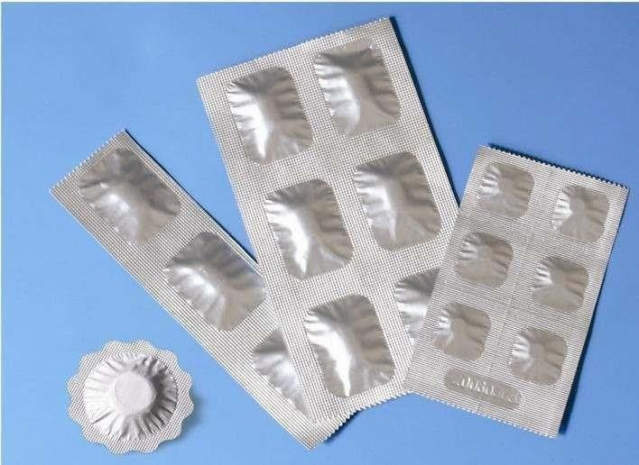

### Strip Packaging

1. **SECONDARY PACKAGING:-**

It is the packaging which is in contact with the primary packaging. It involved –

* + Cartoons (printed).
  + Corrugated boxes (CB).
  + White board box.
  + Corrugated boxes consist of 3 ply or 5 ply or 7 ply as per requirement.
  + When secondary packaging is complete a BOPP tape (Bio Oriented Poly Propylene Tape) is use for sticking.

## The purposes of packaging and package labels

Packaging and package labeling have several objectives:

**Physical protection -** The objects enclosed in the package may require protection from, among other things, shock, vibration, compression, temperature, etc.

**Barrier protection -** A barrier from oxygen, water vapor, dust, etc., is often required. Permeation is a critical factor in design. Some packages contain desiccants or Oxygen absorbers to help extend shelf life. Modified atmospheres or controlled atmospheres are also maintained in some food packages. Keeping the contents clean, fresh, and safe for the intended shelf life is a primary function.

**Containment or agglomeration -** Small objects are typically grouped together in one package for reasons of efficiency. For example, a single box of 1000 pencils requires less physical handling than 1000 single pencils. Liquids, powders, and granules need containment.

**Information transmission -** Packages and labels communicate how to use, transport, recycle, or dispose of the package or product. With pharmaceuticals, food, medical, and chemical products, some types of information are required by governments.

**Marketing -** The packaging and labels can be used by marketers to encourage potential buyers to purchase the product. Package design has been an important and constantly evolving phenomenon for several decades. Marketing communications and graphic design are applied to the surface of the package and (in many cases) the point of sale display.

**Convenience -** Packages can have features which add convenience in distribution, handling, stacking, display, sale, opening, reclosing, use, and reuse.

**Portion control -** Single serving or single dosage packaging has a precise amount of contents to control usage. Bulk commodities (such as salt) can be divided into packages that are a more suitable size for individual households. It is also aids the control of inventory: selling sealed one-liter-bottles of milk, rather than having people bring their own bottles to fill themselves.

## Packaging machines

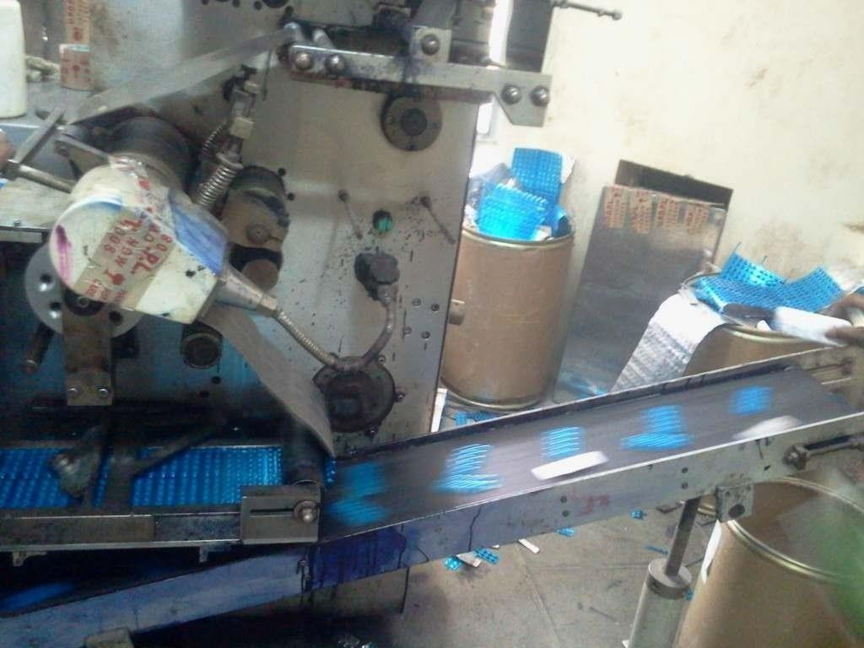A choice of packaging machinery includes, technical capabilities, labor requirements, worker safety, maintainability, serviceability, reliability, ability to integrate into the packaging line, capital cost, flexibility (change-over, materials, etc.), energy usage, quality of outgoing packages, qualifications (for food, pharmaceuticals, etc.), throughput, efficiency, productivity,

25

High speed conveyor with bar code scanner for sorting transport packages.

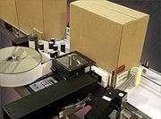

Label printer applicator applying a label to adjacent panels of a corrugated box.

### Packaging machines may be of the following general types:

* Blister packs, skin packs and Vacuum Packaging Machines.
* Bottle caps equipment, Over-Capping, Lidding, Closing, Seaming and Sealing Machines.
* Cartooning Machines.
* Box, Case and Tray Forming, Packing, Unpacking, Closing and Sealing Machines.
* Cleaning, Sterilizing, Cooling and Drying Machines.
* Conveyors, Accumulating and Related Machines.
* Feeding, Orienting, Placing and Related Machines.
* Filling Machines: handling liquid and powdered products.
* Package Filling and Closing Machines.
* Form, Fill and Seal Machines.
* Inspecting, Detecting and Checkweigher Machines.
* Palletizing, Depalletizing, Unit load assembly.
* Product Identification: labeling, marking, etc.
* Wrapping Machines.

# CONCLUSION

In the end I am glad to tell you that training in Akums was an excellent and fabulous experience. During the training I actually learned about the Pharmaceutical Company and above its working the theoretical knowledge is worth for getting a degree, and it is accessible in the book. We can only imagine about the thing we read, but practical life is always different and excellent one. During My training period, I had seen the various instruments and apparatus in the industry. The highly sophisticated instruments that work precisely must be operated with intense care for optimum use. We could acquire a lot of information regarding the latest instruments and their working procedures.

Similarly from practical point of view a pharmaceutical company is very difficult. During the training session I tried to my level best to gain practical knowledge as much as I can. I improved my basic classified doubts and also understood the importance of maintaining of quality of products at Pharmaceutical Company.

I was successfully able to complete my short venture of training. Lastly I hope that my training report fulfill the intended requirements.

Regards

Harshit Third Year B Pharm (Sem-6th)